**1. Summary:**

The project’s client is Professor Rob Capon, who is a group leader within UQ’s Institute for Molecular Bioscience(IMB). Professor Rob Capon and his team have developed a bait that turns the Cane Toad’s own toxin against them by luring tadpoles into simple homemade traps. The development team have created a solution which is delivered in two parts: 1) The Cane Toad Challenge mobile application and 2) a desktop website. The solution aims to provide information to the general public about the technology as well as updating everyone involved on the various developments of the initiative. The mobile application allows users the ability to: register and order baits to trap the cane toad tadpoles, upload catch data, view a leaderboard of the top 5 users, view a tally of each state's total catch amount, and join is on the gamification of the challenge. The desktop website provides admin functionality including viewing orders, managing shipments, and viewing catch data. It also provides information about the Cane Toad Challenge for potential users to know more about the initiative.

The mobile app has been designed using web technologies (e.g. HTML, CSS, JavaScript, PHP, MySQL, etc.) and wrapped using Apache Cordova. This design choice was chosen (as opposed to building a native app) to maximize the team's ability to apply their existing skills while also increasing the ease of developing across multiple platforms. We felt that this design choice for development was the most appropriate to both the skills of our team and the needs of the client.

The “Cane Toad Challenge” app is targeted at potential participants in the challenge, which includes rural farmers, citizen scientists, community groups, students and other members of the public. People may see cane toad in the wild, or suffering from the spreading of cane toads in their local area, they can order baits and traps and submit their cane toad catch information through the App, so that to participant into Cane Toad Challenge. The admins of Cane Toad Challenge can approve or deny the orders request from user through Cane Toad Challenge desktop website.

The team will use this report to outline the following topics:

* Frequently Asked Questions(FAQ) about the product including questions about installing, setting up and using the app.
* An installation manual, which is separated into two parts, desktop website and mobile application.
* A thorough functional testing plan, which covers all functions that were developed.
* A user evaluation report containing three components: UX Expert Evaluation, Usability Testing, and Mobile Device Testing.
* A reflective critical evaluation that critiques the team in different perspectives.
* An overview that explains the structure of source code and product functional coverage.
* An updated system architecture diagram.
* Appendix items relevant to the report or the product.

**2. FAQ**

**Why should I use Cane Toad Challenge app?**

IMB researchers are working with communities to tackle the devastating environmental and economic impact of cane toads across northern Australia, and we need your help to join the challenge. You can use the app to get to know more about the challenge, and to participate by ordering baits and using the baits to catch the

cane toad tadpoles.

**Why should I use Cane Toad Challenge website?**

The website serves the purpose of advertising, to let the users get to know about Cane Toad Challenge before they decide to use the app. The website provides basic functions, registering a user, viewing information about Cane Toad Challenge, and other administrative functions if users log in using administrator accounts.

**What browser should I use to view the website?**

All browsers including Chrome, IE, Safari, Firefox, Edge, Opera and etc.

**Can I use the App on my Android/Apple system phone?**

You can use Cane Toad Challenge app on many devices including iPhone, iPad, Android, Windows and feature phones.

**What are the system requirements for the website?**

There is no particular system requirements to browse through the website.

**Can I use the app offline?**

All functions in the app require internet connection.

**How do I register using the website？**

Go to Home → Register → Enter the information including full name, age, email address, create a new user name, choose a photo from the browser to be the user icon, and set a new password for the account. When all the account information are filled in, read and agree to the CTC Terms & Conditions to successfully register.

**Why is age required in the register form?**

Age is required in the register form. Only users whose age are 18+ can register and use the Cane Toad Challenge app. If the age of the user is below 18, he/she may not be registered successfully. This is because the app provides the function to order baits for the purpose of catching the cane toad tadpoles. The user should be aware that the baits contain chemicals and are toxic. The user must use all due care and take all steps to ensure that the baits are handled safely. Without limiting this obligation, the Registered Participant must ensure that the baits are kept away from animals, handled to avoid skin contact.

**What can I do with the website?**

There are 5 tabs that you can explore in the website: Home, About, Leaderboard, Help, and Contact Us.

“Home” allows you to register for Cane Toad Challenge account.

“About” allows you to get more information about Cane Toad Challenge.

“Support” tells user how to support IMB’s Cane Toad Challenge research project.

“FAQ” contains tutorials of how to catch cane toad tadpoles and FAQ about the website.

“Contact” allows you to enter your contact information and message the IMB team directly.

**How do I register using the app?**

Go to Home → New User → Enter the information including full name, age, email address, create a new user name, choose a photo from the browser to be the user icon, and set a new password for the account. When all the account information are filled in, read and agree to the CTC Terms & Conditions to successfully register.

**How to use the app**

There are 6 tabs that you can explore in the app: Home, Leaderboard, Tally Room, Group, Dashboard, and FAQ.

“Home” displays the map containing catch number in different area.

“Leaderboard” displays top 5 users who have caught the most.

“Tally Room” displays cane toad catching amount in different states and territories in Australia. You may choose 2 states to compare their cane toad catching information.

“Group” displays groups that you belong to.

You can click on each group that you are in to view different challenges that the group has set. If you are the group owner of the group, you can create new challenges for the group by clicking the “+” sign at bottom left corner.

To create a new challenge, you should enter the “Goal” of the challenge, and its start and due date, as well as the challenge description. After all the information are entered, click on “Create” button to create the new challenge.

If you want to create new groups, you can click on the “+” button below the existing groups’ names.

To create a new group, you should first enter a unique group name, and write down the group description. Then you can key in the usernames of the users that you want to add into the new group. After all the information are entered, click on “Create” button to create the new group.

“Dashboard” contains four major functions: “My Profile”, “Make Order”, “Order History”, and “Data History”. You may edit your account details in “My Profile”; place an order of baits by entering address details in “Make Order”; check your order status in “Order History”; and you can check your catch information in “Data History”.

“FAQ” contains tutorials of how to catch cane toad tadpoles and FAQ about the app.

**3.** Installation manual

**3.1 Desktop Website**

The first and the most basic implementation of our solution is the desktop website.

In order to join the challenge, a user will need to click on the registration button on the homepage, fill out their details and agree to the terms and conditions agreement of registering for the challenge.

**3.2 Mobile App**

The mobile app provides more comprehensive functionalities for users to engage with the initiative. Eventually, once the application is finalised by the client, users will be able to download the app directly from the app store or android store. Until then, developers and test subjects can run the application on a mobile using the Cordova toolkit, or alternatively access the mobile site through a mobile web browser (access via firefly.uqcloud.net/App/index.html).

Once opened, a user can either register for the first time (if they have not already done so on the desktop website) or sign in using their account credentials.

4. Functional Testing Plan

Our testing strategy involved targeting the main areas for our project and testing them as thoroughly as possible. The main features which were looked at was the order, data upload and account creation and login. These were determined to be very important areas which needed to be testing for security and consistency. The backbone of the application was to allow for registered upload and response to user data which through our testing has been completed to a satisfactory level with little to no problems.

Due to the nature of the application most of these pages/functions were web based and were then susceptible to web based attacks such as MYSQLI and XSS. These were combatted through sanitize inputs in regards to what the user communicated to the server as well as confirmation and other security protocols when it came to the upload of an image. These inputs were also then tested with incorrect or outrageous information to test client side constraints which aim to reduce the number of these submissions.

With the app being located on a mobile application all of the inputs needed to be device friendly and secure. Some tests which were involved in the mobile part were to do with image capture and upload. This was implemented so that the user could take a picture on their device and then upload it through our app. This would then be given to the admins to review. This was tested with a wide variety of devices and a wide variety of images which would then be uploaded to test functionality. All of the tests were then reviewed and changes and bug fixes were taken in response.

The key testing points we decided on were as followed:

* Login
* Registration
* Uploading Data
* Admin suite

**Login testing**

-To ensure users can access their created account to use member functionality.

Inputs: Username and Password

|  |  |  |  |  |  |
| --- | --- | --- | --- | --- | --- |
| # | Description | Inputs | Expected Output | Pass/Fail | Comment |
| 1 | Test that the system handles incorrect logins correctly | Incorrect username and password combination | The login is rejected and the user is notified | P | Notified through alert box |
| 2 | Test that the system handles no data inputs | Nothing | The user is notified that they need to enter both a username and password | P | - |
| 3 | Test that the system handles correct logins correctly | A correct username and login for a non-admin account | The user is redirected to the dashboard where they will have user permissions | P | - |
| 4 | Test that the system handles correct admin login | A admin account is correctly logged in | The admin user is redirected to the admin suite with permissions | P | - |

Tested by Ryan 18/10/2016

**Registration testing**

-To ensure that new users are able to create and use a new account

Inputs: Username, Password, Email, First name, Surname, Age and Mailing Address

|  |  |  |  |  |  |
| --- | --- | --- | --- | --- | --- |
| # | Description | Inputs | Expected Output | Pass/  Fail | Comment |
| 1 | Test that the system handles missing information | Partial completion of registration form | System notifies the user information is incomplete and no data is submitted | P | Notification isn't clear |
| 2 | Test that the system handles non unique email or username | A non unique email or username | System notifies the user that they need to have a unique email and a unique username | P | - |
| 3 | Test that the system handles non matching password | Two different passwords | The user is notified that their passwords need to match | P | - |
| 4 | Test that the system handles a correct registration | Complete registration information | The user’s account is created and the user is redirected to the login form | P | - |

Tested by Ryan 18/10/2016

**Upload catch data**

To ensure that the user uploads correct and usable data

Input - Location, image, comment and count

|  |  |  |  |  |  |
| --- | --- | --- | --- | --- | --- |
| # | Description | Inputs | Expected Output | Pass/  Fail | Comment |
| 1 | Ensure all forms of input are filled | Partial form completion | User is notified that they need to fill all forms. No data submission | P | - |
| 2 | User selects an invalid type of image | All form inputs but an invalid image | User is notified that their image is invalid and no data is saved | F | Notification wasnt triggered but data wasnt saved |
| 3 | Ensure suspicious data is filtered | A outrageously large catch number | Data is saved but admin is notified when reviewed | P | - |

Tested by Ryan 18/10/2016

**Admin Suite testing**

To ensure that all admin functionality is working

Inputs -Dialogue box options

|  |  |  |  |  |  |
| --- | --- | --- | --- | --- | --- |
| # | Description | Inputs | Expected Output | Pass/  Fail | Comment |
| 1 | To test admin functionality to display information works | User clicks on the appropriate button to display the information they’re interested in | The page is populated with the resulting information | P | Css problem were found with the admin page body |
| 2 | Test whether an admin can approve or deny an order | Admin clicks on the “view pending orders” and then either confirms or denies then. | The action is saved into the database | P |  |
| 3 | View an uploaded catch data | Admin clicks on “view catches” and then clicks on the image to view it | The image is displayed for the admin to view | F | Some images depending on extension wouldnt show |
| 4 | Change status to sent for an order | Admin clicks “View confirmed orders” and clicks “shipped on appropriate orders | The order is marked as shipped and the user could then upload catch data for it | P | - |

Tested by Ryan 18/10/2016

5. User evaluation report

1. The Cane Toad catch map effectively displays the detailed catch information throughout catch locations. Which forms a good display of where to find cane toads in your local area.
2. Group page, Order Page and Contact Page in mobile app provide comprehensive information and an introduction for users to browse and participate in the application.

This section describes the results of the evaluation activities carried out during the development phase of the desktop website and mobile app. The evaluations were conducted over a period of 3 months from August 2016 until October 2016 and consisted of three components:

* UX Expert Evaluation
* Usability Testing
* Mobile Device Testing

The methodology for the evaluations is mentioned5 in Usability.gov (https://www.usability.gov/how-to-and-tools/methods/usability-evaluation/index.html) and ALL ABOUT UX (http://www.allaboutux.org/all-methods) .

**5.1 UX Expert Evaluation**

Introduction: UX experts use the system or walk through the concept description, and write down all positive and negative findings that affect the user experience of the evaluated concept. Also, evaluators mark whether the finding is pragmatic or hedonic by its primary nature. Below are the comments and feedback from users:

**5.1.1 Positive Findings:**

* Functionality:

1. All the page accessibility features are fully functional without any error, which provides a potential and positive effect on user experience.
2. About page, Support page and Help page on the desktop website give a distinctive description and project direction to express our project purpose and invite users to join the Cane Toad Challenge community.

* Design:

1. As the entry of desktop website, the home page design gives users a good impression of the credibility of the site, and the order of pages in navigation are organized by most useful to least useful.
2. The simple interface of the mobile app is a good way for users to get used to using the app on a regular basis.

**5.1.2 Negative Findings:**

* Functionality:

1. In the desktop website, there is only basic functionality for users to go through and it would definitely be better to add in some of the functionalities included in the mobile app (e.g. leaderboard, tally room, etc.).
2. The Leaderboard in the mobile app does not present a good data comparison for users to understand the impact that each of those users is having on the successfulness of the challenge.

* Design:

1. The design of navigation bar and header in the desktop website could be improved with a better color scheme.
2. The layout of the home page and login page on the desktop website should not contain the empty white space at the bottom of the screen.

**5.2 Usability Testing**

Usability testing refers to evaluating a product or service by testing it with actual users which represent the target audience. Typically, during a test, participants will Students can access the project website to learn about the Cane Toad Challenge knowledge by watching the video and project materials.

try to complete typical tasks while observers watch, listen and takes notes. The goal of usability testing is to identify any problems, collect qualitative and quantitative data and determine the participant's satisfaction with the product. Here is the comment and feedback from users:

* Rural Users (e.g. Farmers, wildlife workers, etc.)

1. The website application is a useful platform for rural residents who are living in the places without a mobile internet connection and they can use their computer to go into our website by using house network to get acknowledge with the latest news of Cane Toad Challenge.
2. Most of the farmers are get in ages and they prefer to use computer to browse information to help them and the teaching video for cane toad trapping is one of the good example for them to learn how to catch the cane toad in their farms.
3. However, it only provides basic functions in the website application and the rural people suggested there should be included all the functionality in the website application, such as the order page and upload photo pages should be mentioned in the further improvement.

* Community Groups (e.g. school classes, researchers, scout groups, etc. )

1. Mobile application has a powerful data collection functions and it can be display visually by different format and style, including the Cane Toad Catching Map, Leaderboard, etc.
2. It is convenient for researchers to browse all the information they need at the mobile app in anytime, anywhere only with the connection of mobile network.
3. It is simple for administrator to engage with and maintain the new system by following the introduction of the website application and mobile app application.

* Urban Users (citizens, students)

1. The mobile app application is easy to use and it can be updated frequently

**5.3 Mobile Device Testing**

Testing mobile devices such as phones, tablets, and eReaders requires special equipment and methodology. Since traditional desktop screen-capture software cannot adequately capture touch interactions, usability practitioners have been using strategically placed cameras to record usability test interactions on these mobile devices. Below are the comments and feedback from mobile-device users:

* Positive Feedback:

1. As the major platform that we use for our Cane Toad Challenge project, the mobile app application provides the complete functionality for users to interact with the project and any mobile device such as mobile phone, tablet will be available to use our application.
2. As the mobile device testing section, users can easily register and login to the application and finish the whole testing section in our expected time.
3. Mobile users have shown their interest in our several functions, which is Cane Toad Catching Map, Catching photo upload function, Leaderboard and Tally Room. And these functions or pages are our best achievements in our application development.

* Negative Feedback:

1. The application design can be improved by challenge a lighter color scheme and change some layout of the pages.
2. The reflection speed of Cane Toad Catching Map is not prompt and it sometime display the wrong suburb in the location.
3. A comment page for the cane toad catching photo could be implemented in the mobile map, which would be a good way for different users to share their Cane Toad Challenge experiences.

6. Reflective critical evaluation

**Team management and Process reflections**

The scrum master is in charge of managing the team members’ work and performance of the team. Communication among the team members was conducted through a Facebook group. All members were active to share their ideas and opinions in the group. Files including documentation and design documents were shared within the private Facebook group. Tasks division and product development progress were recorded in Trello board.

We held informal meetings in the studio sessions every week. All members have attended the meetings unless valid reasons of absence were informed the team members via Facebook messages. During each of the weekly meetings, each members demonstrated the progress of the individual tasks. Members discussed and scrum master assigned tasks for the following week/sprint to individuals. Tasks were distributed to members equally, according to their strengths.

Scrum master has sent emails to the client frequently, reporting the progress that the team has made. Meetings with client were held at the end of every sprints. Progress of the project was discussed in detailed with client. Feedback from the client was recorded and documented in the meeting minutes. The team then create changes or updates to the product according to the client’s feedback.

Scrum master has taken in charge of checking the progress of each tasks distributed to the members, ensuring all members have been working on their tasks. Quality of work was looked after by the scrum master throughout the project. There was nearly no major disagreement amongst the members. However, there were a few divergences of opinions upon the development of product functions. Members managed to prevent the conflict by discussing, and fair decisions were made eventually.

There were a few problems that the team had during the project. One of them was that the team has spent majority of the time implementing the product, time that was left to produce reports was too little. Although the reports were finished in time, but if the team could have better time management to reserve more time for reports, it would have increased the quality of the reports. Another problem that the team had during the development process was unequal skill sets of team members. There were two members working on the backend of developing the product, it was found that it was a huge workload for these two members. To overcome this problem, another member learned the basics of PHP language to share the tasks of backend.

In summary, the team has worked together towards the goal of implementing the product. Problems that occurred in the team were overcome by adopting team management process.

**Design assessment**

**App：**

There were 3 design phases during the implementation of the product: initial sketch, framework design and final design.

**Initial sketch:** pre-analysis, planning interaction flow

After gathering requirements from the client, features that the app should provide are listed as following:

1. Welcome page
2. Suitable for iPhone and Android
3. User register/login
4. Onboarding
5. Dashboard
6. Collection of data
7. Display catch number by postcode on a Google Map
8. Provide information
9. Gamification opportunities
10. Social sharing

The initial sketch has been produced according to the features required from the client. Login/Register were designed to be placed on the welcome page. Home page would display a google map where cane toad catching numbers were placed on top of each area. Four tabs were placed at the bottom of the screen, these were: Dashboard, Order, Game, and FAQ, while Dashboard was the default home page. Order tab would provide two functions to users: Order new baits or Check order status. Game tab allowed users to view groups, join groups, view challenge and set new challenges. FAQ would provide cane toad tadpole catching tutorials and other links that were related to Cane Toad Challenge.

After the initial sketch was produced, several problems were discovered:

1. The interaction flow in between each function was not clear enough.

2. Some functions were overlooked (edit profile, upload catch data, etc.)

To solve the first problem, a sitemap has been produced. It allowed the interaction flow of different features to be presented clearly. There would be 5 major function (tabs): Main Page, Leaderboard, Group, Me, and Help. Similar to initial sketch, main page would display a google map showing cane toad catching number. A tally of total cane toad tadpoles caught would be placed in the home page as well. A new function “Leaderboard” was added, which would display top users who have caught the most cane toad tadpoles and their caught numbers. Different than how the initial sketch has designed, “Game” tab would be replaced by “Group”, where users could choose to view the existing groups or to add new groups. Games – challenges could be viewed or created by visiting the existing groups. “Me” tab involved four major functions, view profile, make new order, check order status and upload catching data. “Help” would contain same contents as the initial sketch.

**Framework design:** mockups, standardizing elements, dummy

Framework design of the app UI was produced. The overall structure has strictly followed the site map designed at the previous phase. The purpose of this phase was to standardize the style of the interface (color theme, fonts, icons and layout).

At this phase, different layouts and arrangements has been explored. The framework has covered all functions and interaction between different functions. The team started to build the app based on the framework design. Along with the development, a couple of problems with the framework were discovered.

1. It would be redundant to display two separate leaderboards namely “Everyone” and “Friends”.

2. Data upload should only be accessed by users who have shipped orders.

3. It created confusion by having “Search User” function to add users to the group.

After demonstrating the minimum viable product to the client, client was fairly pleased with the design. Some suggestions of changes were raised by the client:

1. Users should upload their own photos to be the avatars.

2. Add in “Tally room” function which displays total catching data of users’ in each states in Australia. Comparison should be able to be make between two different states.

3. Payment can only be done using PayPal, no other methods of payments are allowed.

4. Users should not be required to fill in the shipping address another time while ordering. The address information was already recorded at registration.

**Final design:**

As the layout and structure of the elements of the framework design has met the client’s requirements, only a few changes were made on the final design.

To resolve the problems discovered in the framework design, following changes were made:

1. Only top five users with the most cane toad tadpoles caught were listed in the leaderboard.

2. Data upload function was taken out from the Dashboard, and placed under “Check Order” function. Only users who get shipped orders would be able to see the “Upload catching data” button to upload data.

3. “Search User” function was removed.

Other changes were made to meet client’s requirements:

1. In Register and My Profile functions, users would be able to upload photos to be the app avatar.

2. Tally room function added.

3. Other payment methods were removed.

4. To place an order, users would only be required to click on the “I would like to participate” button, not address information would be required to be filled in.

In addition, the navigation tabs were removed from the bottom of the screen, but placed at the top left corner as a tab collection to make the interface look tidier.

In overall, the final design has met the client’s requirements, it has also met the design principle which was stated in Return Brief document:

Simple, convenient and intuitive to use；

100% cross platform compatibility；

Emphasis on iPhone；

Compliance with the Apple Human Interface Guidelines；

Use of the IMB Cane Toad Challenge branding；

Functions to allow the users to participate in game like competitions；

Including various data entry such as location, photo of catches etc

Website:

There were 2 design phases during the implementation of the product: Initial ketch and Final design.

**Initial sketch:** pre-analysis, planning interaction flow

After gathering requirements from the client, features that the desktop website should provide are listed as below:

1. Home page.
2. Login/Register page.
3. About page.
4. Help page.
5. Contact page.

The initial sketch has been produced according to the features required from the client. Login/Register were designed to be placed on the Home page. As the decoration of home page, a Cane Toad Challenge Banner will be displayed at the top and a welcome style background image will be placed in the middle. When user first enter the website, the Homepage will invite users to join our Cane Toad Challenge community and users can also go through all the pages in website including About page and Leaderboard page to know more about our Cane Toad Challenge knowledge and inspire them to join in our project.

After the initial sketch was produced, two problems were discovered:

* The layout and color scheme of the website does not follow the style guide from the client requirements.
* The Support page and Admin page should be designed and included in the desktop website.

To solve the first problem, firstly the layout of website needs to be redesigned as the requirement, which required to improve the HTML document of all the pages. On the other hand, the website color scheme has to be changed to the purple, which was mentioned by client in the style guide. In order to fix this problem, the CSS document needs to be update as the correct background color and lighter color reflection of navigation style.

To solve the second problem, the two new pages need to be created and implemented in the website application. One of them is the Support page, which contains most of the Cane Toad Challenge information and the link of Donation for Cane Toad Challenge project. Admin page is the most important page that needs to be implemented in the website application. As to create a fully functional Admin page, the cooperation and collaboration between website and mobile app is necessary.

**Final Design:**

For the final design of website application, the problems that we faced in the initial design are being fixed and implemented with new features in the final design.

Here is the new pages layout for the website application:

1. Home page.
2. About page.
3. Support page.
4. FAQs page.
5. Contact page.
6. Admin page (Admin login).

First and foremost, the website application has implemented a new functionality page of the Admin Interface, which can help system administrator to modify, administrate and maintain all the information of the Cane Toad challenge mobile app. In the Admin page, users can browse all the registration-users information, approve/decline the order of cane toad trap, modify the group information and view all the catching data throughout the whole of Australia.

Secondly, the Support page and FAQs page display plenty of project information and catching experiences to help users easily deal with their problems. The website also provides two social media links at the top right corner for users to Like/Share and contact with the IMB Institute for special enquiry.

In conclusion, the website background layout and color scheme have been updated to follow the requirement of client’s style guide, in order to provide the best user experience in Cane Toad Challenge application.

**Critique of final product**

In overall, the outcome of the final product is satisfying. All functions except Paypal which were required by the client were implemented.

From the UX Expert Evaluation in User Evaluation Report, it could be found that, positive feedback was given to the functionalities. All features are fully functional without errors. Negative opinions were given over the desktop website that it only provides basic functionalities. The reason that the website contains less information than the mobile app is mainly due to time limitation. The team has chosen to spend more effort implementing the mobile app as it is the major delivery of the product.

As most of our group members prefer to use HTML, CSS and JavaScript as the programming language. In order to use one code to build a cross-platform app, we choose to use the Cordova framework to help us build the App instead of develop a native mobile app by using iOS or Android programming language.

By using Cordova framework, we use the web technologies to build the front end of the application. But compare with the native languages, the data processing speed on JavaScript is much slower. The reflection speed of Cane Toad Catching Map is not prompt and it sometime display the wrong suburb in the location. Because JavaScript are not providing background processing through multi-threaded. However, the native language can calculate the GPS position in the background. So if we have chosen to use the native language instead of Cordova framework, we may provide a more smooth user experience.

**Future development plans**

To get the desktop website and mobile app fully developed, some of the functions are needed to be developed:

1. **PayPal function on mobile app**

As it requires PayPal Business or PayPal Premier account to enable using PayPal in a mobile app, this function has yet to be developed. This function can be implemented in future to allow users to pay for shipping costs. It will complete the ordering function when PayPal is fully implemented.

1. **Group, Tally Room and Leaderboard functions on desktop website**

These functions can be developed on desktop website to allow the website to be more functional to users who do not own a smartphone.

There are features that can be added to the mobile app to increase its functionalities:

1. **Sharing to social media platform via app**

A share button can be placed on the corner of the screen to allow users to share the link of the app to selected social media platform. It would increase awareness and thus more people will use the app to contribute to Cane Toad Challenge.

1. **Friends adding**

A “Friend” function can be added to allow users to add friends by searching user name. It will make the app more user friendly.

1. **Chat function**

A “Chat” function can be implemented in the app to allow users send messages to others. Users can then share their views or information about Cane Toad Challenge between each other.

7. Source code overview

The code for this project was heavily based on PHP and MYSQL. In PHP, session, database and image upload functionality was implemented and used extensively. For client side technology, we used JavaScript and JQuery for input checking and Ajax calls to the database to provide the user with an easy and straightforward experience when it came to logging in and admin functionality. These two approaches allowed for a functional and easy to understand source code and product.

The first section is the JavaScript and JQuery for the client side coding. Most of the functions which used JavaScript had to do with graphs, maps or administration. The major part being administration. When admin logs in, they will be taken to the administration panel where they will be able to confirm, deny, ship and monitor shipped and catch responses. For these to display they are tied to a button click which then fetches data from the database and returns it back into the web page through JQuery. The PHP behind this is a simple MYSQL statement and then formatting the data it receives. For the map and graphs, data is taken from the database and then fed into these libraries to have a clean and functional element.

The second section is the PHP. More complex than the client side scripting, PHP is the backbone for this product and allows for most - if not all functionality. The files were located in their own folder for neatness and to allow for easy includes of other required files. Connect.php was included all files which accessed the database in some way, allowing the order to connect to the database and start the session which was used to keep track of a logged in user. Membership.php was used to make sure only logged in users could access certain pages on the website. All other php pages were fairly similar with the trend being collect the data given, format it, sanitize it, validate and then submit it to the database. PHP files which pulled data followed a similar set of instructions but in reverse order.

8. Functional Coverage:

The following features have been fully implemented and are shown to be working:

* Making an order of baits
  + The app allows the user to make an order/request to participate in the project
* Uploading catch data
  + Only on valid orders (so a user cannot upload information if they have never received baits)
  + Uploading of Location, Image, and count of tadpoles
  + Location data is displayed as pins on a map
  + Automatic flagging of suspicious catch numbers (Default >75000)
* Viewing of catch data
  + User can see their previous catches
    - Image
    - Number
    - Date
* Group functionality
  + A user can create a group (only one)
  + A user can join a group (any number)
  + A user can see the challenges set by the group leader
  + Group leader can set challenges for the group with a start date, end date and goal number
* Leaderboards and Tally rooms
  + Leaderboards show who the users with the top 5 total cumulative catches are (ignores flagged catches so a user cannot just say they caught 17 billion tadpoles)
  + Tally room lets the users compare catches based on different metrics (for example state vs state)

**9. Updated system architecture diagram**

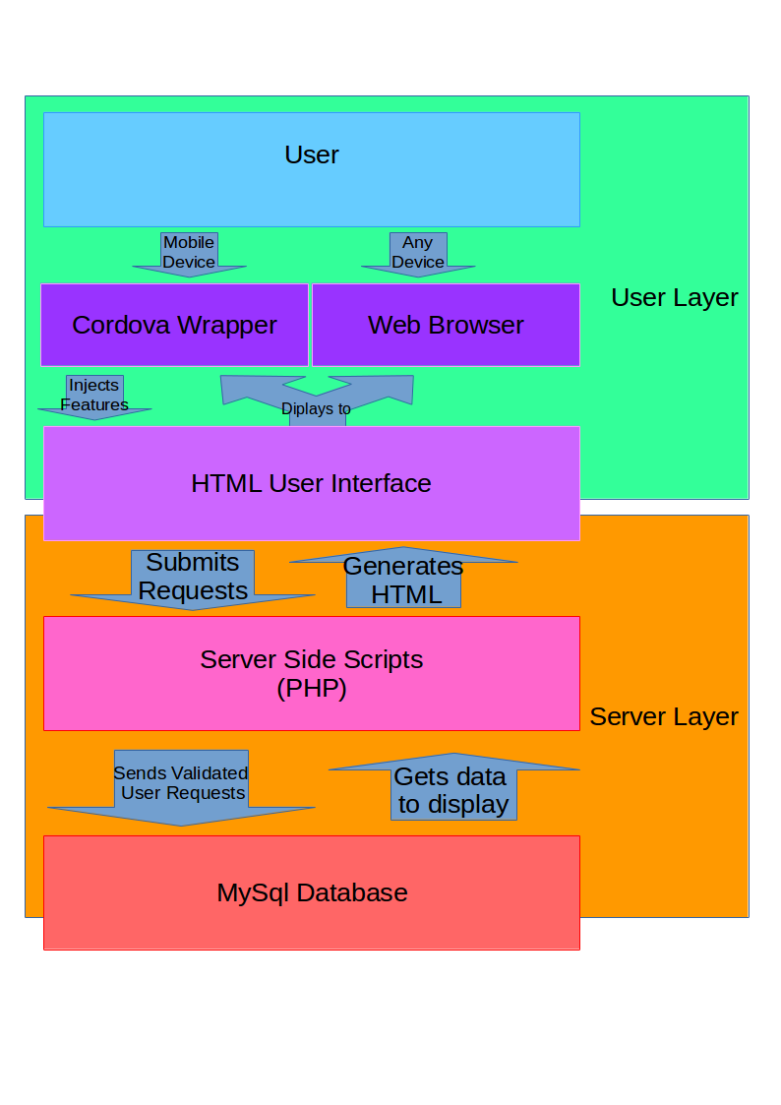

**Appendix**

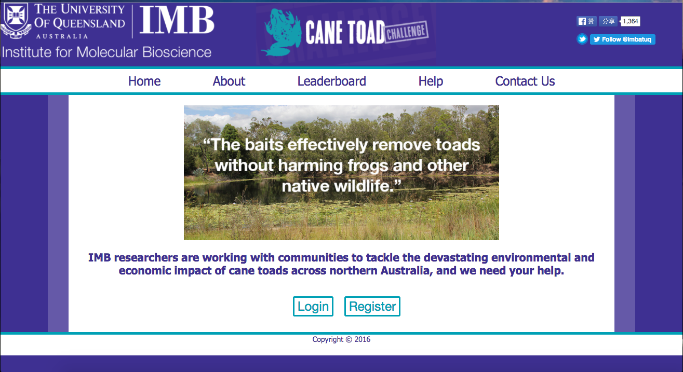

Figure 3.1 Home page of desktop website

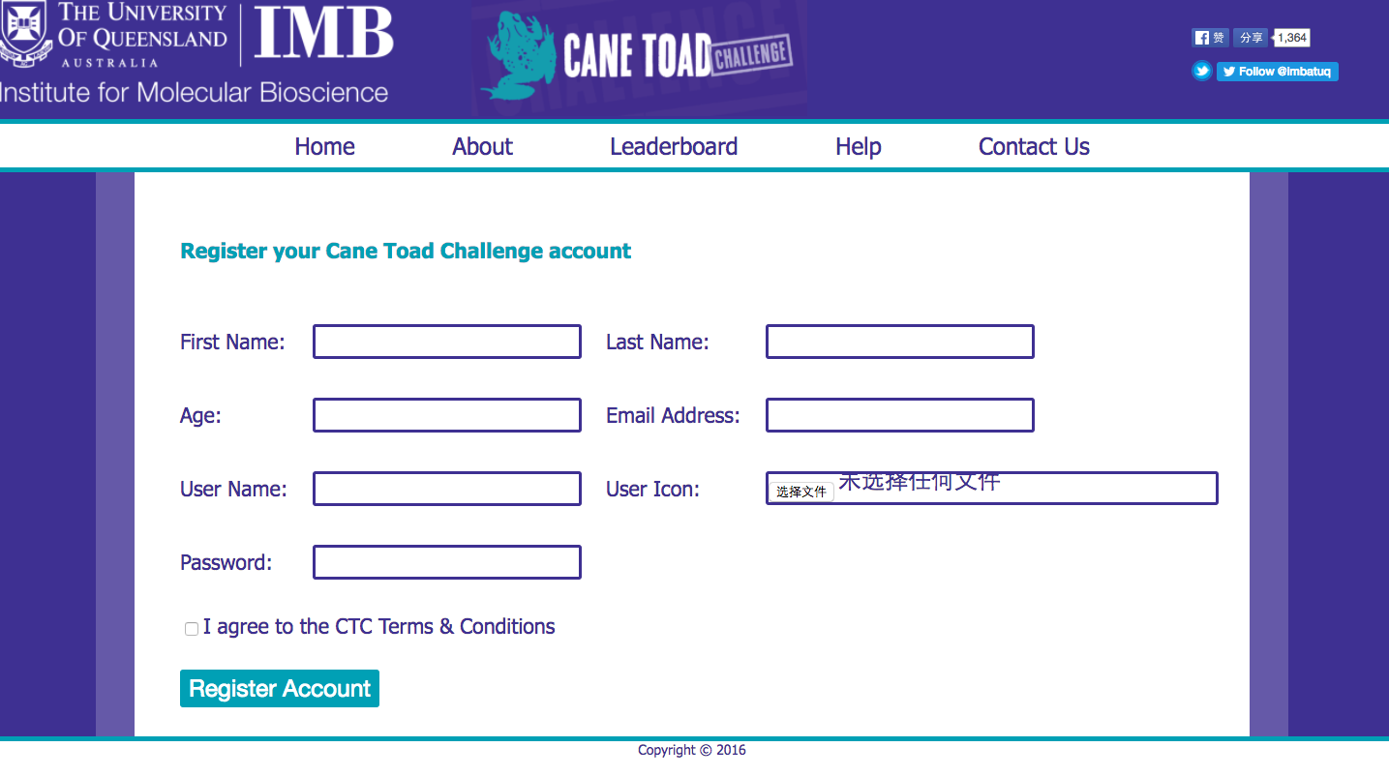

Figure 3.2 Register page of desktop website

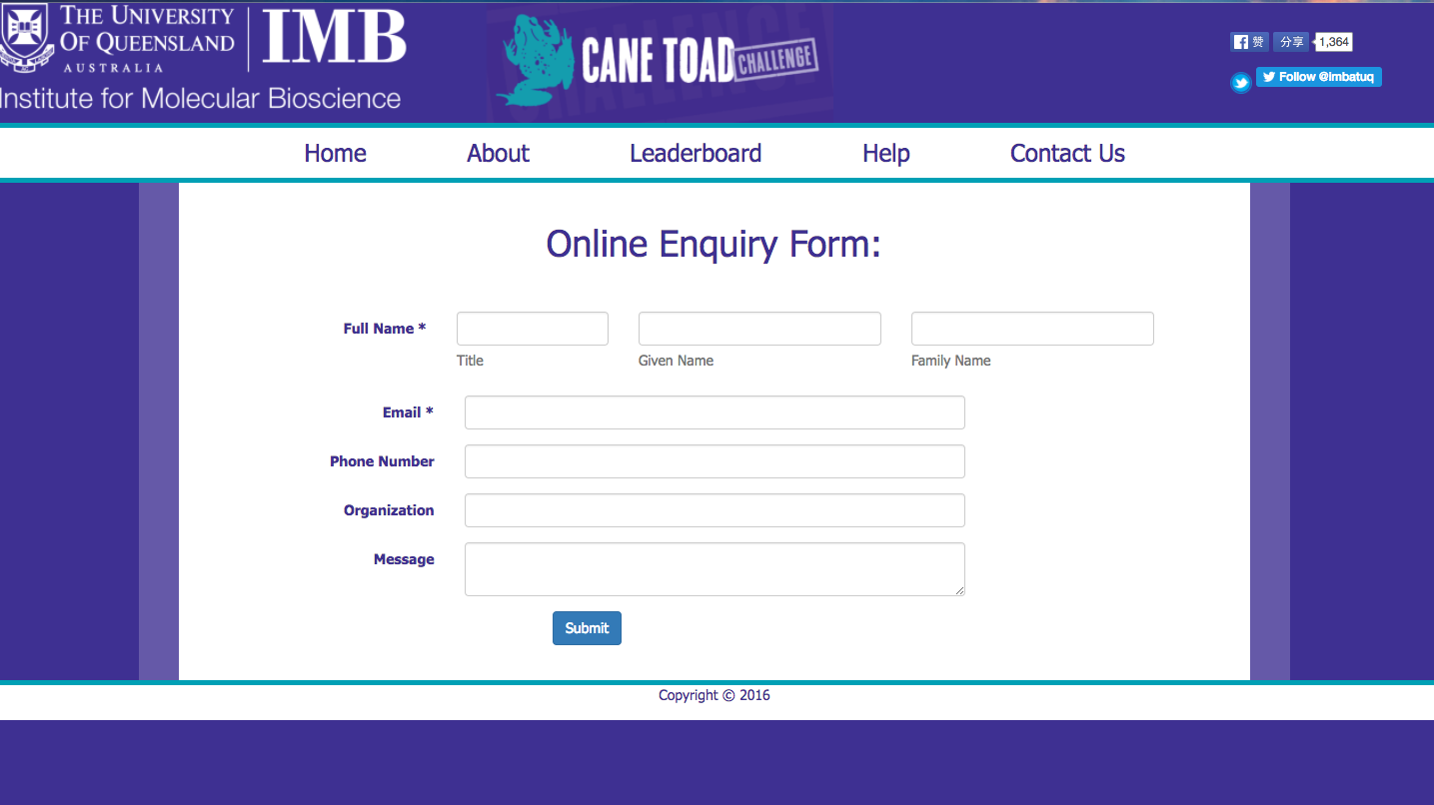

Figure 3.3 “Contact Us” page of desktop website

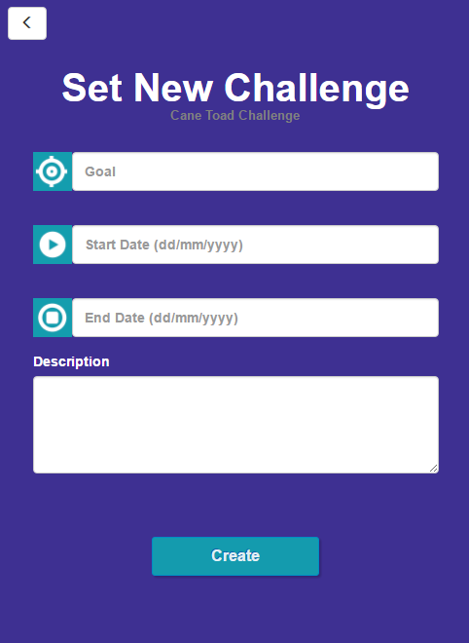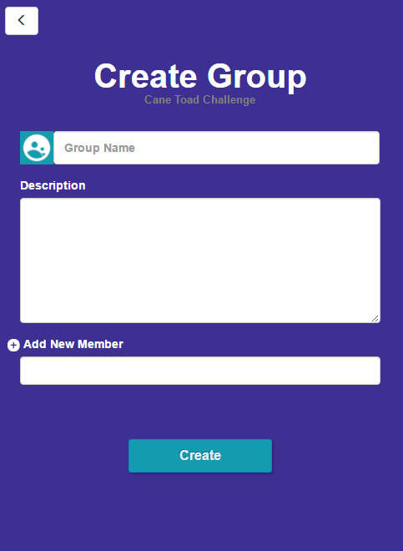

Figure 3.5 Setting challenge and create group functions of mobile app

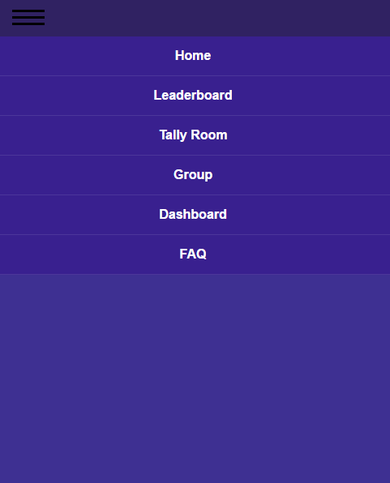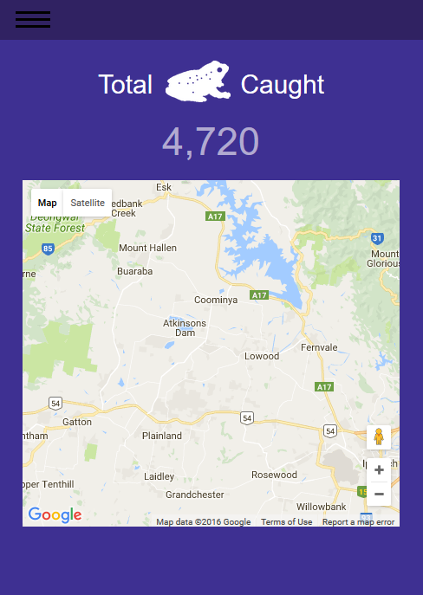

Figure 3.4 Home page and navigation menu of mobile app

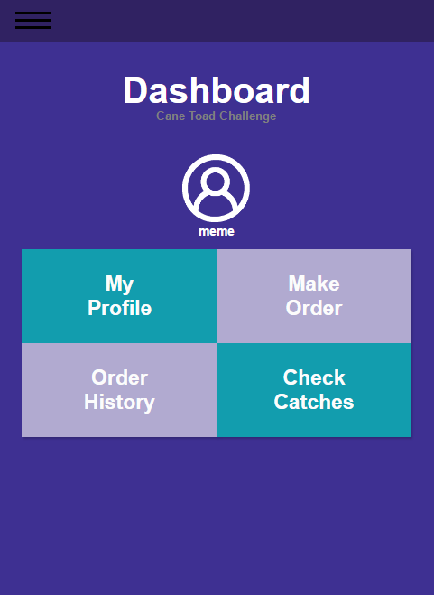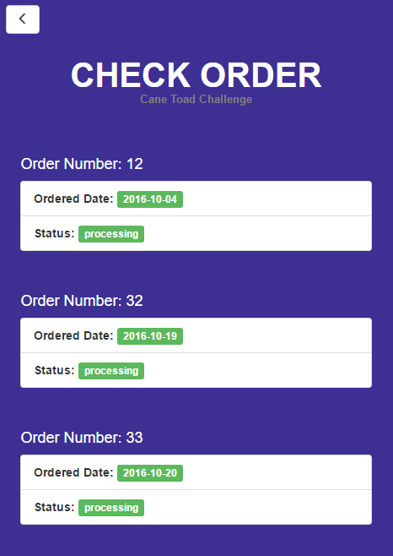

Figure 3.6 Dashboard and check order functions of mobile app

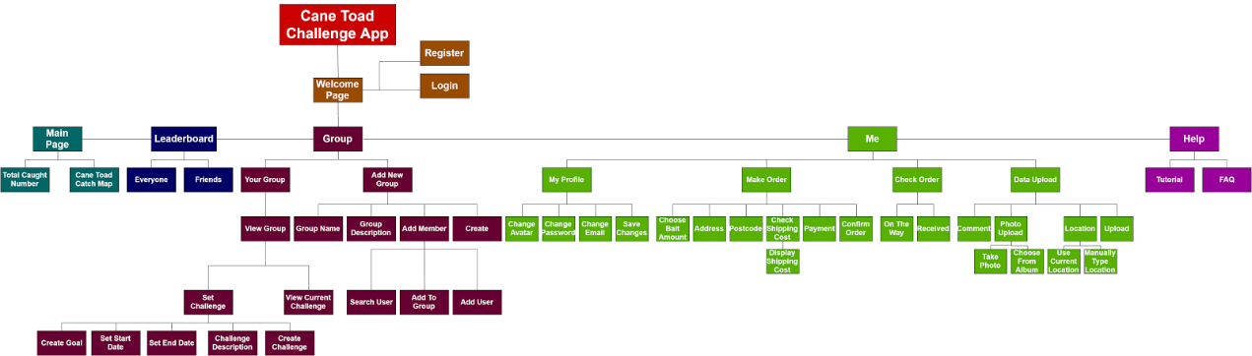

Figure 6.1 Mobile app site map overview

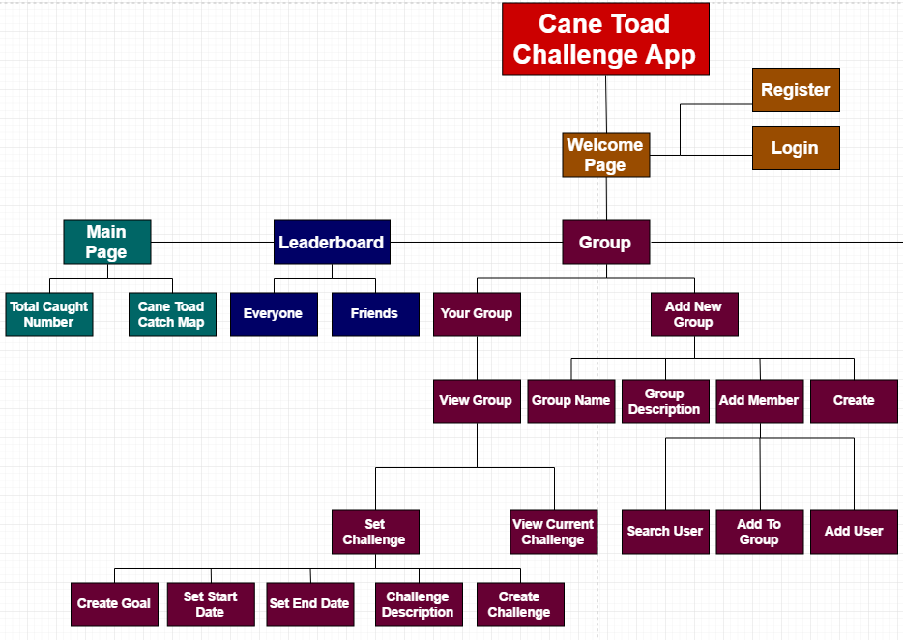

Figure 6.2 Mobile app site map detail (I)

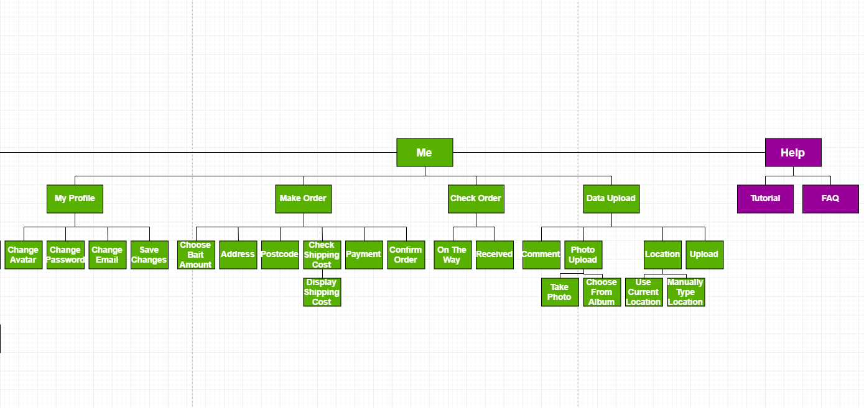

Figure 6.3 Mobile app site map detail (II)

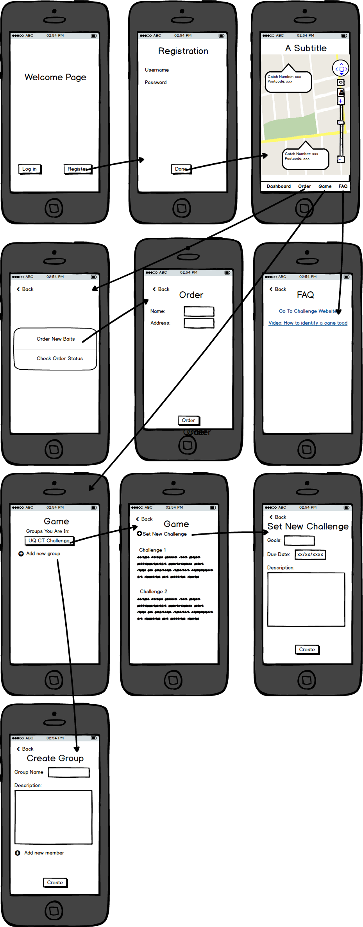

Figure 6.4 Mobile app initial sketch(I)



Figure 6.5 Mobile app initial sketch(II)

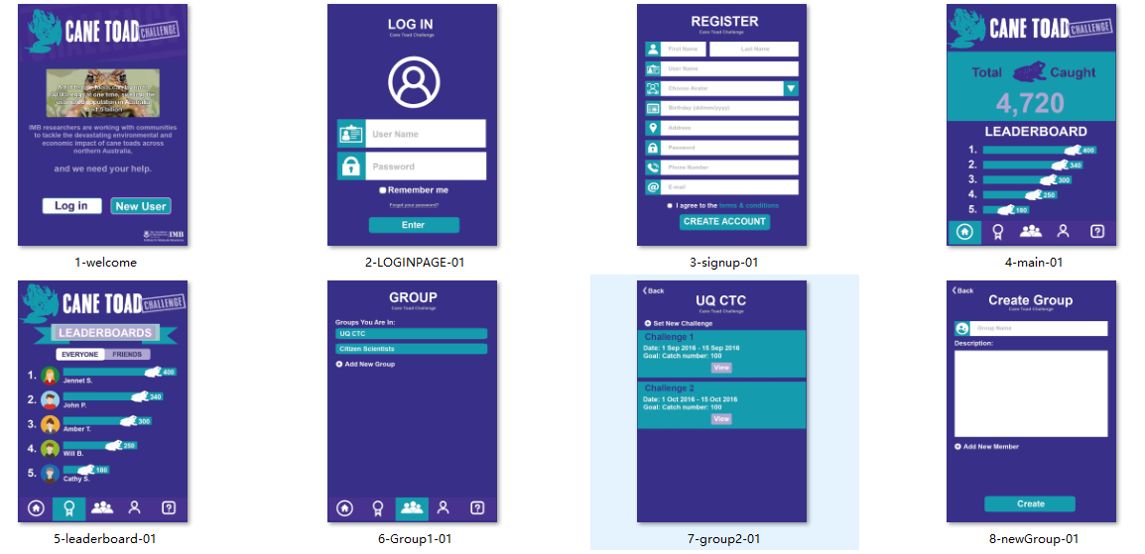

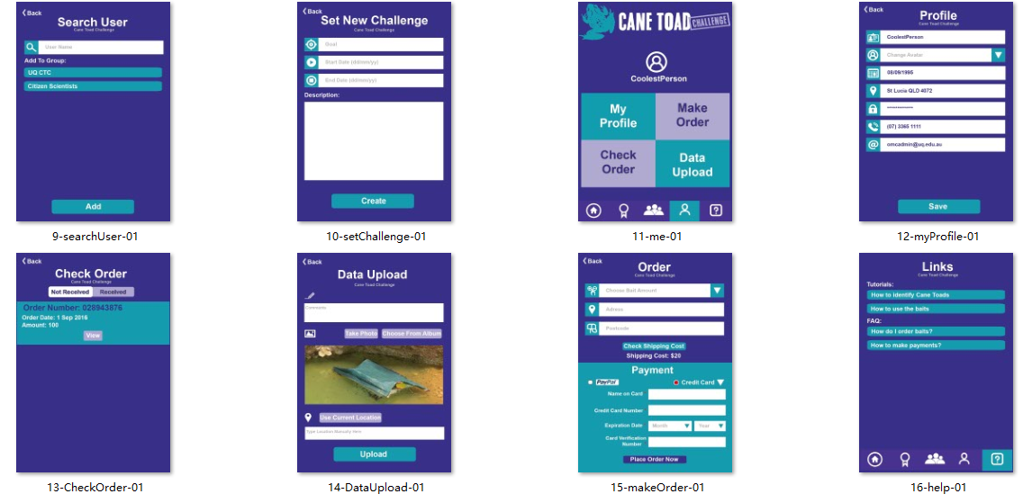

Figure 6.6 Mobile app Framework Design

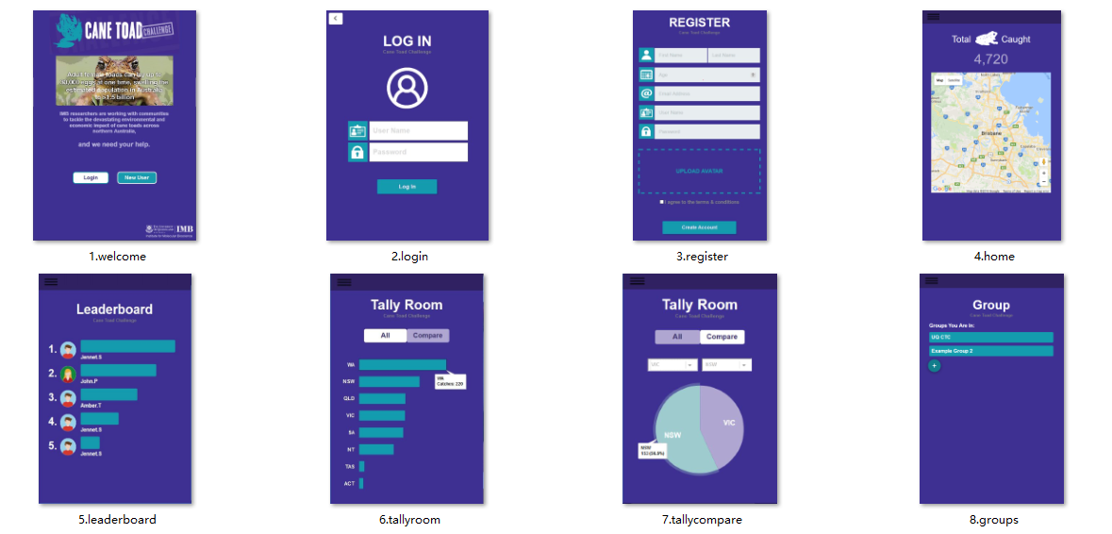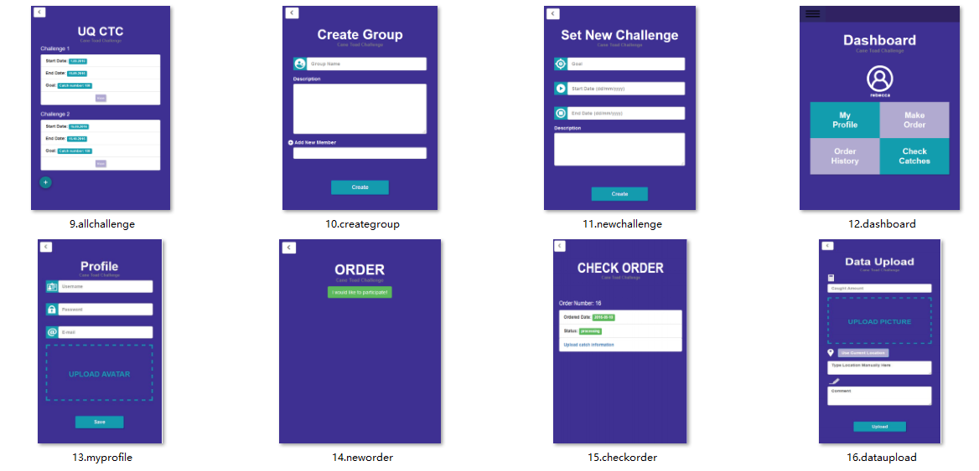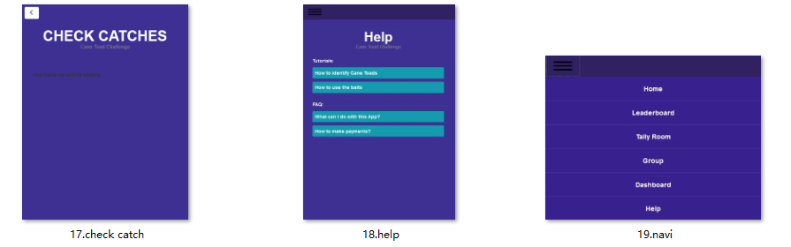

Figure 6.7 Mobile app Final Design